ServletContextEvent and ServletContextListener

the ServletContextEvent is notified when web application is deployed on the server.

If you want to perform some action at the time of deploying the web application such as creating database connection, creating all the tables of the project etc, you need to implement ServletContextListener interface and provide the implementation of its methods.

### **Constructor of ServletContextEvent class-**

here is only one constructor defined in the ServletContextEvent class. The web container creates the instance of ServletContextEvent after the ServletContext instance.

1. ServletContextEvent(ServletContext e)

TWO METHODS-



EXAMPLE->

In this example we are going to make one SevletContextevent in which when the server is started

The connection for sql is automatically get connected-

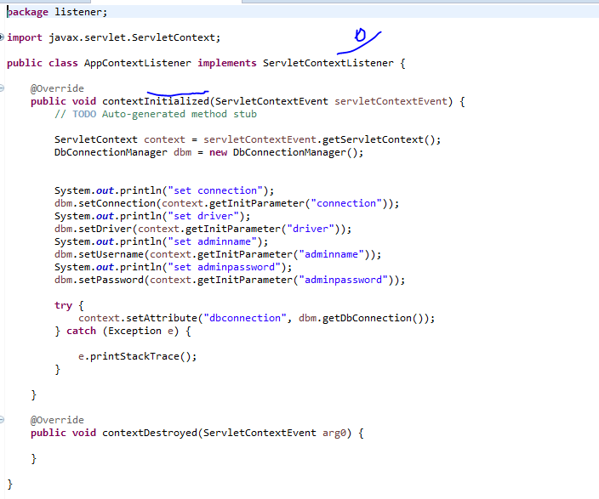

HOW to call listener from web.xml

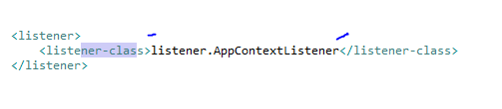

In this we just tells the name of class AppContextListener which implements the **implements** ServletContextListener